The Prelude

**\*Chiming of the Hour**

**\*The Call to Worship**

Let’s sing to God,

**For God is here.**

Let’s sing of love,

**For love is here.**

Let’s sing and rejoice,

**For here our souls are restored.**

**\*Hymn** “Guide Me, O Thou Great Jehovah” UMH 127

**\*The Opening Prayer**

**Ever-present God, Even as you are present with us this day, we yearn to feel your presence in our midst each and every day of our lives. Speak to us with words of grace. Reveal yourself with the power of your love. Flow over us with the presence of your Holy Spirit. Help us know the glory of your love and experience the wonder of your grace. In the name of your love, we pray. Amen.**

**Welcome and Announcements**

**The Children’s Message**

**Time of Sharing and Prayer**

Joys and Concerns

The Pastoral Prayer/The Lord’s Prayer (UMH 895)

**\*Hymn** “Rock of Ages, Cleft for Me” UMH 361

**\*Psalter** Psalm 95 UMH 814

**\*Affirmation of Faith** Apostles’ Creed UMH 881

**\*Gloria Patri** UMH 70

**The Receiving of God’s Tithes and Our Offerings**

**Offertory**

**\*The Doxology** UMH 95

**\*The Prayer of Dedication:** Living God, through these gifts we now bring, help your world live. Loving God, through these gifts we now bring, help our world love. Nourish others as you have nourished us with your steadfast presence and your healing grace. **Amen.**

**The New Testament Reading** – Romans 5:1-11 p. 1697

**The Gospel Reading** – John 4:5-42 p. 1599

**Prayer for Illumination**

**The Message**  *The Strangest People Are Called*

**\*Hymn** “A Charge To Keep I Have” UMH 413

**\*The Charge and Blessing:**

Blessed by God’s love and strengthened by Christ, our Living Water, we go to bless God’s world with love. Go in peace. **Amen.**

**\*Response** “Blest Be the Tie That binds (v. 1) UMH 557

**\*Chiming of the Trinity/Postlude**

*\*Please stand as you are able.*

**Assisting with Wors**h**ip Today Mar 22, 2020_____**

**Scripture Readers** Pam Hunter  Tina Lauber

**Greeters** _______________ Volunteer Needed

**Volunteers Needed:** The sign-up sheet for March and April is available now.

**Welcome Cards –** We welcome all our guests. There are welcome cards located in the pews. Please take a moment to fill one out and place it into the offering plate during the collection.

**About Fletcher’s Chapel Church**

**Our Vision** is to be a beacon in the name of Jesus Christ to the world, to make disciples of Jesus Christ and to send them forth to proclaim God’s Word and serve God’s will everywhere and always.

**Our Mission:** “19Go therefore and make disciples of all nations, baptizing them in the name of the Father and of the Son and of the Holy Spirit, 20and teaching them to obey everything that I have commanded you. And remember, I am with you always, to the end of the age.” -- Matthew 28:19-20

**Email:** [barryburkholder@vaumc.org](mailto:barryburkholder@vaumc.org) or [fletcherschapel@verizon.net](mailto:fletcherschapel@verizon.net)

**“Like” us on Facebook:** Search for “Fletcher’s Chapel UMC-King George, VA” and when you find our page, click “Like” so you can keep up with the latest news and events at Fletcher’s Chapel.

**MINISTERS: All Members**

**PRESIDING BISHOP: Sharma D. Lewis**

**DISTRICT SUPERINTENDENT:** [**Charles F. Ledlum-Bates**](mailto:RappahannockRiverDS@vaumc.org)

**PASTOR: Barry Burkholder**

**LAY LEADER: Marie Williams**

**MUSICIAN Elizabeth Pruett**

**Fletcher’s Chapel United Methodist Church**

**8330 Fletcher’s Chapel Road, King George, VA 22485**

**www.fletcherschapel-kinggeorge-va.org**

**Church: (540) 775-7247 Parsonage: (540) 625-2539**



**Third Sunday in Lent, Mar 15, 2020 9:00 a.m.**



**Mar 15, 2020 – Mar 22, 2020**

**Sunday, Mar 15**  **9:00am** Worship **10:15am** Sunday School

**Weds, Mar 18 10:00am** Heritage Hall Nursing Home Ministry

**Sunday, Mar 22**  **9:00am** Worship **10:15am** Sunday School

**Upcoming:**

**Weds, Mar 25 10:00am** Morning Prayer Group

**Sunday, Mar 29**  **9:00am** Worship **10:15am** Sunday School

**Weds, Apr 1 10:00am** Heritage Hall Nursing Home Ministry

**Sunday, Apr 5** **9:00pm** **Communion Sunday/**

**Canned Food Collection 10:15am** Sunday School Opening

**Weds, Apr 8 10:00am** Morning Prayer Group

**Thurs, Apr 9 6:00pm** Finance Committee

**6:30pm** Administrative Council

**Sat, Apr 11 9:00am** United Methodist Women Meeting

**Sunday, Apr 12** **9:00am Worship/Loose Change Collection**

**10:00am** **Coffee Fellowship** (Hosted by Tina & Chris Lauber)

**10:30am** Sunday School

**Birthdays**

**3/17 John Stevens,**

**3/18 Vince Heironimus, 3/19 Diane Pelletier, 3/20 Shayne Heironimus,**

**3/24 Paul Smith Sr., 3/26 Robert (Bob) Hunter, 3/27 Brian Williams,**

**3/29 Louise Henderson, 3/30 Stephenie Newton, 3/31 Carissa Emory**

**† † †**

**Confirmation Classes to begin this afternoon!**  Classes will be held on Sunday afternoons from 1:00pm to 2:30pm starting this afternoon.

**Suggested Bible Readings for next Sunday, March 22:**

Old Testament: 1 Samuel 16:1-13

Psalm: 23

Epistle: Ephesians 5: 8-14

Gospel: John 9:1-41

**2020 Census:** The 2020 Census is here and your response helps King George County (or the county/city where you live) receive the appropriate resources to serve our neighbors. Your timely response online, by phone, or by mail is critical. Each person is worth approximately $20,000 in government funding including SNAP, highway funds, Head Start, and more. Everyone counts no matter their race, creed, color, citizenship, or age. Personal Census data is secured for 72 years. Do your part to help us all, respond to the Census. If you have questions you can go to 2020Census.gov or call the King George Census Complete Count Committee at 540-775-4386.

**Please let Debbie Rogers** know of any upcoming announcements or calendar events that you would like to have included in the bulletin, on the website calendar and/or announced on the church Facebook page! Please also notify her of any cancellations as soon as possible so we can let everyone know ahead of time! The bulletin is completed by every **Thursday afternoon at the latest** although sometimes it has to be completed before that. She can be reached at: [rcsmom@msn.com](mailto:rcsmom@msn.com) or at 540-273-1459. If it is a last-minute change or addition, please call. Thank you for your assistance.

**Prayer Concerns:**

**Prayers for our Community and the World:** The congregation and guests of Fletcher’s Chapel and our community; the residents and staff of the Thurman

Brisben Center; Our Bishop and her cabinet.

**Prayers for Our Church Family:** Dee Campbell, Delores Coates, John Earl Coates, Robin DeWaters, Ruby Hawkins, Louise Henderson, Grace Radolinski, Bob Hunter, Evelyn Jackson, Lolita James, Turner Minx, Linda Newton, David Pitts, Clifton Seay, Shirley Seay, Jimmy Weadon

**Prayers for our Families and Friends:** Gavin Balderson, Donnie Bullock, Mitchell Burroughs, Michael Canaday, Sr., JoAnn Carpenter, Drew Cleveland, Judy DeWaters, Anne Emery, Judy Fisher, David Frazier, Frazier Family, Gage Ford & Family, Bobby Garner, John Gayle, Anna Graninger, Chip Hall, Clair Hunkins, David Kane, Bishop Sharma Lewis, Nancy Chappell Madison, Jim McCurtain, Jennifer Paling, Joey Rowe, Brian Scott, Jan Sharp, Mike Shelton, Jean Stone, Billy Sullivan, Ryland Tedeton, Mike Warnke, Fred Weaver, Robin Wolanin, Cynne White Wolf

***Prayer Request Cards*** *are available in the pew rack.*

|  |
| --- |
| **News from the District Newsletter:**  **District Discipleship Training April 18 - Multigenerational Mission & Ministry** |
| |  |  | | --- | --- | |  |  | |  |  |   Have you struggled to engage the children, youth, young adults, and older adults in ministry and mission together? Often, we separate our ministries by age. What does the youth group want to focus on? What do the older adults want to be involved in? A gap and a lack of understanding exist between generations these days caused by all kinds of societal issues and technologies. We even find that to be the case in the church. **We as the church have an opportunity to bear witness to how multigenerational individuals of a congregation can work together in mission and ministry.** This is especially important with rural churches that have only a handful of children, youth or young adults. How can we involve everyone and collaborate to do the best ministry we can together?  **We would like to invite all clergy and at least 2 laity from every congregation to our next Discipleship Training Event on Saturday, April 18, 2020.**  The training event with lunch will be at Wright's Chapel from 10 am-2 pm. Bryan Tener, the Director of Contextual Evangelism, Community Engagement & Church Planting, will be here with us from Discipleship Ministries and will lead a workshop on how to go out into our communities to do ministry with a multigenerational team.  Please let your pastor know if you're able to come. Pastors will RSVP to Lynn with a total number that will be attending from your congregation by April 11 for the lunch meal preparation. |

|  |  |  |  |  |
| --- | --- | --- | --- | --- |
| |  |  | | --- | --- | |  |  | |  |  |   Fredericksburg United Methodist Church will have a bone marrow drive this weekend to benefit Jase Hallman, the 7 month old great nephew of Tony & Donna Marino (church members). Jase has Wiskott-Aldrich Syndrome and no other treatments have worked for him.  They have been unable to find a match for him in the family or on the national registry.  This weekend's screening will consist of just a simple cheek swab. You must be between the ages of 18 and 44.  Please help us spread the word to your churches. The event will be Saturday, March 7, from noon to 5 p.m., or Sunday, March 8, from 8 a.m. to 12:30 p.m. Fredericksburg UMC is located at 308 Hanover Street in Fredericksburg.  Please keep little Jase in your prayers. |

|  |
| --- |
| **MOCK ANNUAL CONFERENCE - PRACTICE SESSION** |
| |  |  | | --- | --- | |  |  | |  |  |   Have you ever wondered how Annual Conference seems to flow so smoothly? Practice, Practice, Practice!  ﻿This year, we need your help!  Please come to Wright's Chapel UMC on Tuesday, June 9th, from 6:00 pm to 7:30 pm for a Mock Annual Conference to help prepare for the real thing and prepare our Conference Parliamentarians.  Your presence will be a great help. This is open to anyone from our churches - you don't have to be going to Annual Conference.  As thanks for your participation each Church represented will receive a free recording of our "Programs to Disciple Making" Webinar on flash drive.  Mark your calendars now to attend!  Wright's Chapel is located at 8063 Ladysmith Rd, Ruther Glen, VA 22546.  No registration is necessary, but an email to [BevMyers@vaumc.org](mailto:BevMyers@vaumc.org) of intent to attend would be appreciated. |

|  |  |  |  |  |  |  |  |
| --- | --- | --- | --- | --- | --- | --- | --- |
| |  | | --- | |  | | |  |  | | --- | --- | | |  | | --- | | **Copies of**  **Registration Package located on front bench.** | | | | |  | | --- | | **Lay Servant Training Offered** | | Lay Servant Training can help anyone who is interested in learning more in their pursuit of being a better leader and servant for Christ’s church. These classes can be used as tools in discerning God’s call for your personal walk and ministry.  Classes will include:   * **Basic** * **Leading Public Prayer** * **Lay Servants as Christian Transformational Leaders**   **Registration Deadline April 17**  Warsaw UMC is located at 287 Main Street, Warsaw. | |

|  |  |  |  |
| --- | --- | --- | --- |
| |  | | --- | |  | | |  | | --- | | ***The Scammers are active on our district!***  ***Some of our church members have received fake texts and emails from people impersonating their pastor or district leadership asking for gift cards or other assistance. They are using the pastor's name and title but it is coming from an incorrect email address and phone number.***  ***Don't fall for this - your pastor won't ask for donations in this manner.*** | |

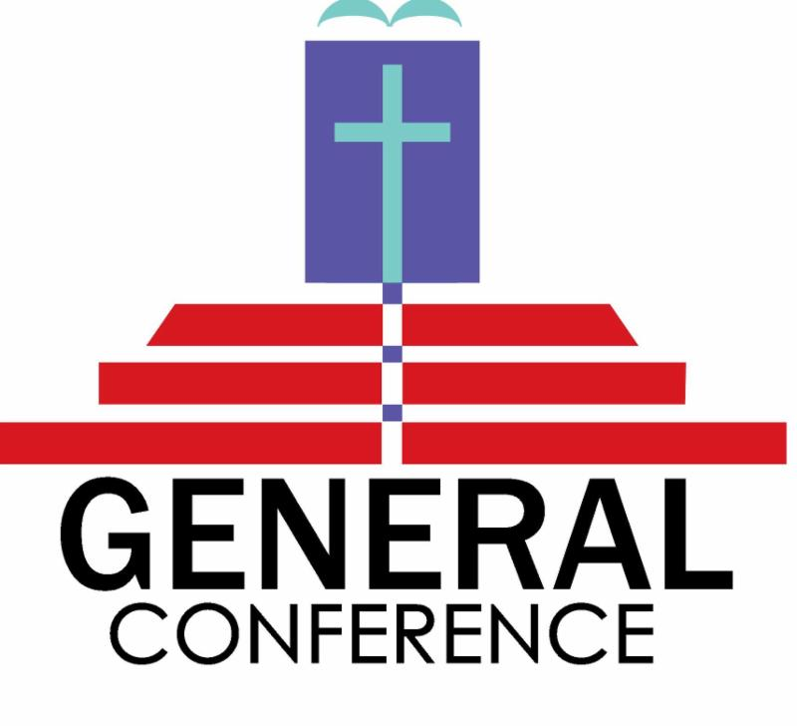

Rappahannock River District Laity,

As you may be aware, a *Protocol of Grace and Reconciliation through Separation* was brought forth as a plan to be presented at General Conference 2020 in May. There have been so many questions regarding what this will mean for the denomination, the conference, the local church, laity, and Clergy.

We, the Clergy Association along with our District Superintendent Charles Bates, want to make sure that you have accurate information, and can have as many of your questions answered as possible.

We will be hosting a laity session with presentations and Q&A with Ms. Martha Stokes and the Rev. Keith Boyette. **The meeting will be Sunday, March 22 from 2:00pm to 4:00pm at Wright's Chapel.** **Wright's Chapel is located at 8063 Ladysmith Road in Ruther Glen 22546 (Ladysmith Exit 110 off I-95).**

If you are unable to attend this event on our district, we invite you to attend one at another district. You can find a list: <https://www.vaumc.org/pages/news/2020news/protocol-sessions> .

Grace and Peace,

Becca Minor

Clergy Association President

Rappahannock River District