Fletcher’s Chapel United Methodist Church
8330 Fletcher’s Chapel Road, King George, VA 22485
Church: (540) 775-7247 Parsonage: (540) 625-2834

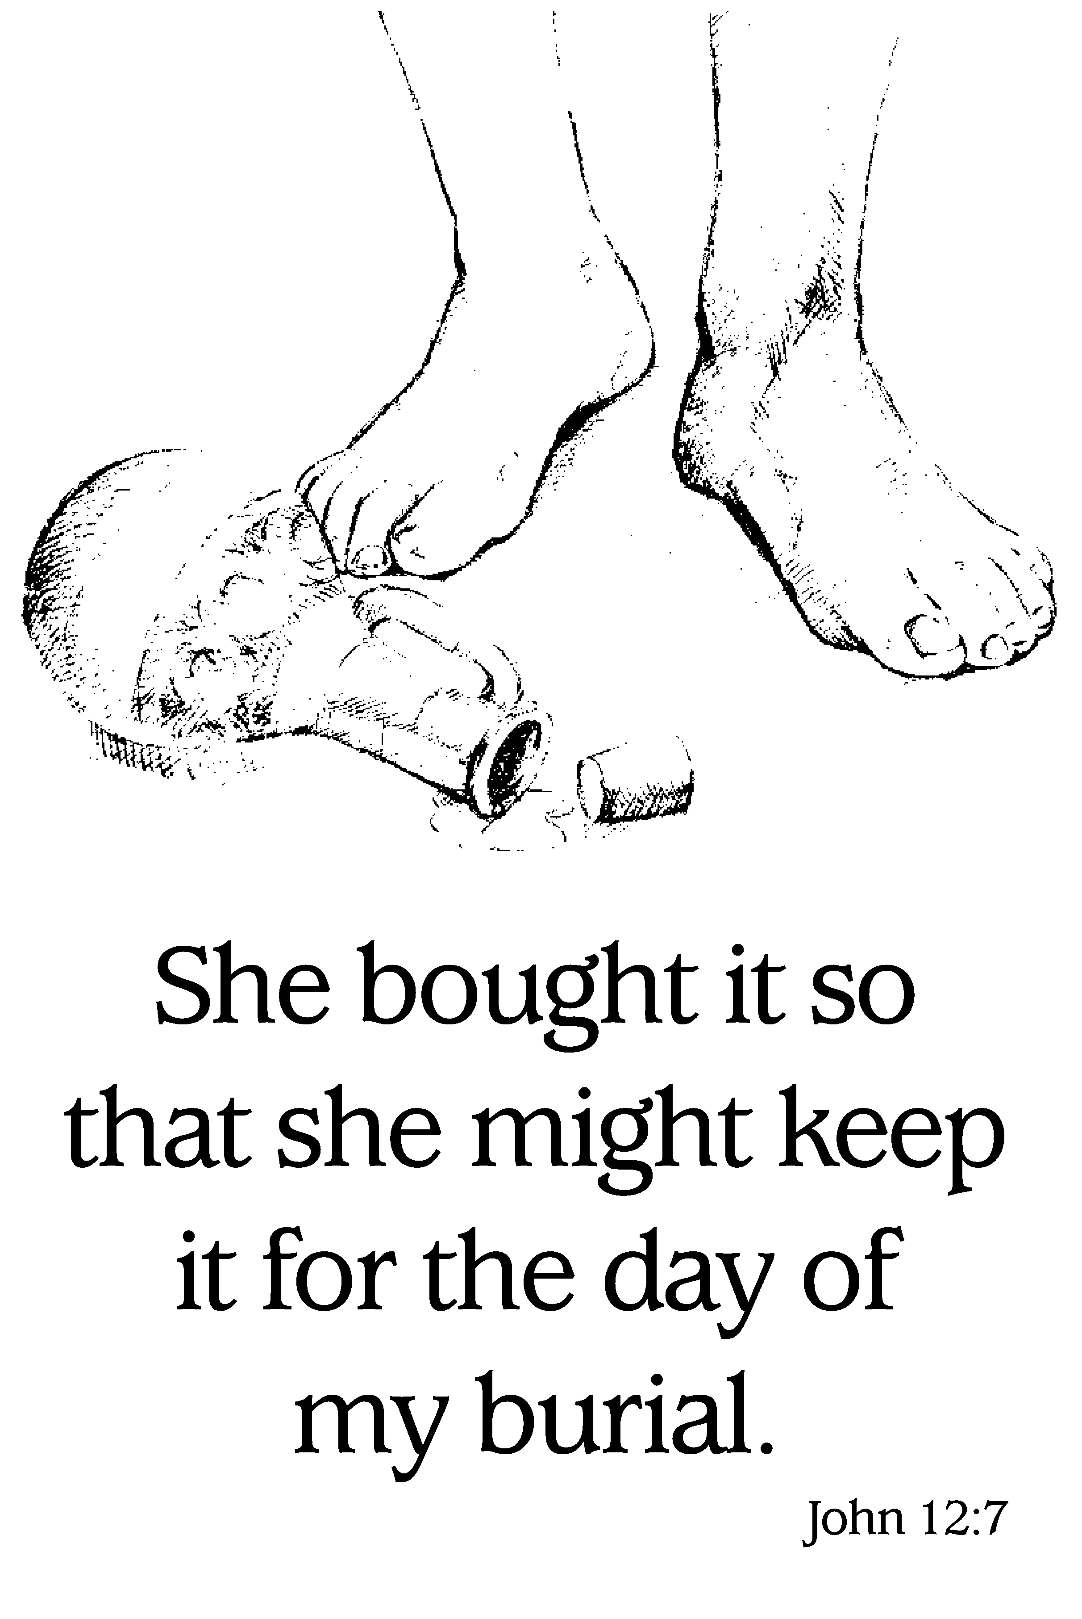

Fifth Sunday in Lent, March 13, 2016 8:30 a.m. & 11:00 a.m.

The Prelude

*Chiming of the Hour

The Welcome and Announcements

*The Call to Worship
When the Lord restored the fortunes of Zion,
we were like those who dream.
Then our mouth was filled with laughter and shouts of joy.
We rejoiced: “The Lord has done great things for us.”
May those who go out weeping, bearing the seed for sowing,
come home with joy, carrying their sheaves.

*Hymn “O For a Thousand Tongues to Sing” UMH 57

The Opening Prayer
Creator God, you have formed us as your own, so whether we are weeping or laughing, dreaming or shouting for joy, we are always coming home to you. For all this and more, we thank you in Jesus’ name. Amen.

Time of Sharing and Prayer
Celebrations of God’s Grace and Prayer Concerns
The Pastoral Prayer/The Lord’s Prayer (UMH 895)

The Children’s Message [Loose Change Collection]

*Hymn “O How I Love Jesus” UMH 170

Prayer for Illumination
Break open the Scripture through the power of your Spirit, O God.
Let your word, read and proclaimed, pour out until its fragrance fills this house and our lives. Then, anointed with your word, send us out to share the good news we have received. We pray in the name of Jesus Christ, who is with us always. Amen.

The Old Testament Reading – Isaiah 43:16-21 p.1096

The Gospel Reading – John 12:1-8 p.1618

This is the Word of God for the people of God.
Thanks be to you, Lord Jesus Christ.

The Message

The Receiving of God’s Tithes and Our Offerings
The Response: “In the Lord, I’ll Be Ever Thankful” (2x)
In the Lord, I’ll be ever thankful, in the Lord I will rejoice!
Look to God, do not be afraid. Lift up your voices, the Lord is near,
Lift up your voices: the Lord is near.
*The Doxology (UMH 95)
*The Prayer of Dedication: Abundant God: You cause water to flow in desert places. You give wine to flow at a wedding feast, and food to feed five thousand on a grassy mountainside. Your generosity astounds and humbles us. We bow before you in gratitude and awe, asking you to receive what we have brought in response. May these gifts be a pleasing and fragrant offering, for the sake of the world you came to save. We pray in your holy name. Amen.

*Hymn “More Love to Thee, O Christ” UMH 453

*The Charge and Blessing:
As the season of Lent turns toward Palm Sunday and the events of Holy Week, go forth remembering both Mary’s faithfulness and Judas’s betrayal as you consider your own life of discipleship.
May God guide you through the desert places, may Christ lead you into knowing him more deeply, and the Holy Spirit fill you with faith overflowing: that as you share in Christ’s suffering, you will also trust the power of his resurrection. Amen.

Postlude “Bless the Lord” (2X)
Bless the Lord, my soul, and bless God’s Holy name.
Bless the Lord, my soul, who leads me into life.

*Please stand as you are able.

All are Welcome to our service of worship this morning. We are glad you are here. Please take a moment to fill out a welcome card and place it into the offering plate during the collection.

Assisting with Worship Today March 20, 2016:______
Scripture Readers: Lucy Willard (8:30) Tina Lauber (8:30)
Greeters: Stephenie Newton (11:00)

Can You Help? Volunteers are needed to read Scripture, deliver children’s and serve as greeters. Please see the sign-up sheets which are on the front center pew.

About Fletcher’s Chapel Church

Our Vision is to be a beacon in the name of Jesus Christ to the world, to make disciples of Jesus Christ and to send them forth to proclaim God’s Word and serve God’s will everywhere and always.
Our Mission: “¹⁹Go therefore and make disciples of all nations, baptizing them in the name of the Father and of the Son and of the Holy Spirit, ²⁰and teaching them to obey everything that I have commanded you. And remember, I am with you always, to the end of the age.” -- Matthew 28:19-20

Contact us by email: Pastor Mike is at reaves.michael.b@gmail.com
The church address is fletcherschapel@verizon.net

Our website is at www.fletcherschapel-kinggeorge-va.org and let us know what you think! Access the calendar of events. Listen to today’s sermon or a sermon you may have missed.

MINISTERS: All Members
PRESIDING BISHOP: Young Jin Cho
DISTRICT SUPERINTENDENT: Theodore Smith
PASTOR: Michael B. Reaves
LAY LEADER: Marie Williams
MUSICIAN: Elizabeth Pruett

March 13 - 20, 2016
TODAY Loose Change Collection
Daylight Savings Time Begins (Spring Forward)
8:30am Worship
9:30am Coffee Hour (Fellowship Hall)
Hosted by the Lauber Family
10:00am Sunday School
11:00am Worship
Tuesday, 3/16 11:00am Week 4 Lenten Study – Daytime Class
7:00pm Week 4 Lenten Study – Evening Class
Wednesday, 3/16 9:30am Heritage Hall Nursing Home Ministry
Sunday, 3/20 Palm Sunday
8:30am Worship
9:45am Sunday School Opening (Sanctuary)
10:00am Sunday School
11:00am Worship
Upcoming:
Tuesday, 3/22 7:00pm Week 5 Lenten Study – Evening Class
Thursday, 3/24 11:00am Week 5 Lenten Study – Daytime Class
Friday, 3/25 7:00pm Good Friday Service
Saturday, 3/26 9:30am Set Up for Sunrise Breakfast
Sunday, 3/27 Easter
6:45am Sunrise Service
7:15am Sunrise Breakfast
8:30am Worship
9:45am Sunday School
11:00am Worship
Sunday, 4/3 Communion Sunday/Canned Food Collection
Friday, 4/29 4:00pm Serving Dinner at Thurman Brisben
Birthdays This Week
3/19 Diane Pelletier

Easter Sunrise Breakfast: This will be a simple breakfast with muffins, donuts, fresh fruit, juice, coffee, etc. We need people to help with set up on Saturday, March 26 at 9:30am. We will gladly accept donations of food items as well.
Virginia Conference Disaster Relief for Tornado Damage: Please take a copy of Bishop Cho’s letter which outlines the destruction that tornadoes caused to several communities in the commonwealth of Virginia, including Tappahannock, this past Wednesday. Consider making a donation to the VA Conference Disaster Response Advance Special #5307. Read the letter for more details on how you can help.

Heritage Hall Nursing Home Ministry meets this week. Every month on the first and third Wednesdays we provide a short program of music, singing, and prayer for the residents, You can meet at the church at 9:30 to carpool or be at the nursing home at 10:00 if you are interested in helping.

Prayer Concerns
Prayers for our Community and the World: The congregation and guests of Fletcher’s Chapel and our community; the residents and staff of the Thurman Brisben Center; Our Bishop and his cabinet.
Prayers for Our Church Family: Colleen Bowie, Jeanne Bullock, Arlene Coates, Delores Coates, Audrey Davenport, Louise Henderson, Gwen Henderson, Grace Humberger, Karis Humberger, Pam Hunter, Evelyn Jackson, Lolita James, McKennah Lauber, Sherri Minx, Clifton Seay, Annette Stahler, Pete Sullivan
Prayers for our Families and Friends: Krystalene Balao, Mikie Barker, Wesley Berry, Clarissa Busby, The Cameron Family, Barbara Canaday, Felecia Cook, Darrell Critzer, The Frazier Family, Gage Ford and Family, Wayne Gallahan, Jake Gallello, Jeff Gilley, Theresa Guarracino, Barbara Hatchell, Adalynn Hawkins, Betty Jubb, Sylvia Kennedy, Elva Kilby, Becky Lafferty, Ronald Marshall, Bryan McGhee, Mike Nave, Adolfo Pangilinan, Lina Perry, David Pitts, Elaine Cooley Pitts, Brad Pruett, Robert Pruitt, Chuck Rabbitt, Hubert Roberson, Patrick Robinson, Sam Robinson, Brent Rowand, Barbara Rowe, Joey Rowe, Malone Schooler, Joseph Sirrels, Ron Seward, Claude Stevens, Mary Stewart, Vickie Stewart, Ryland Tedeton, Joan Wehner, Jen Ulrich
Our Prayers and Sympathies to Ruby Hawkins whose brother, John Luke “Lukie” Kennedy, passed away on Thursday, March 10, 2017.
Our Prayers and Sympathies to Sherman Coates and the family of Gladys Faye Coates who passed away on Saturday, March 12, 2017.

Prayer Request Cards are available in the pew racks.

